Header

QA14: If user is viewing pages as doer and now want to switch as poster. He clicks on Poster tab then which page would be visible to him. Likewise if he switches from Poster to Doer than which page would be displayed.

QA15: What will be the default role of user just after login?

QA16: Will user name be displayed somewhere after login?QA16

QA17: Will user choose username. Which login options would be allowed to login user (username, single email, single phone, multiple emails, multiple phones or any other)?

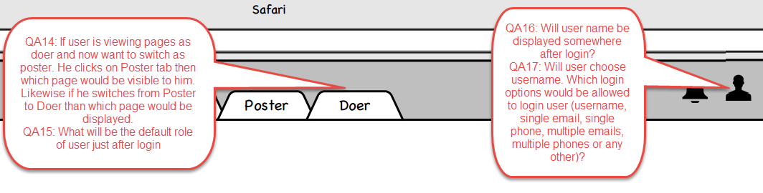

---------------------------------------------------------------------------------------------------------------------------------

Proposal list

QA18: How is Average Experience is calculated. QA18

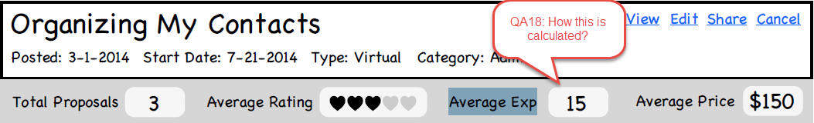

---------------------------------------------------------------------------------------------------------------------------------

QA19: QA19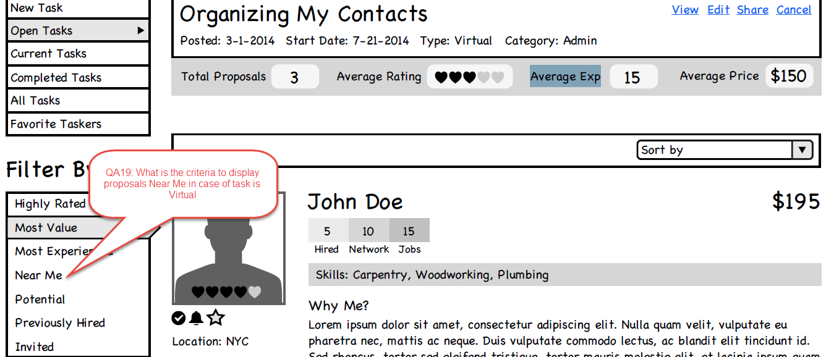

QA20: Is this the total of Hired and Network jobs?

QA20:

QA21: Will jobs done outside/external to site which are added in portfolio be counted here?

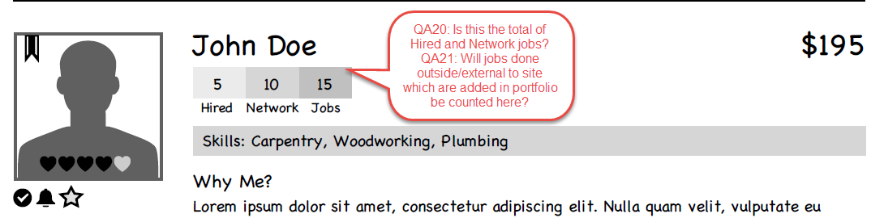

---------------------------------------------------------------------------------------------------------------------------------

QA22: Clicking here will open proposal detail page in separate tab?

QA22: Clicking here will open proposal detail page in separate tab?

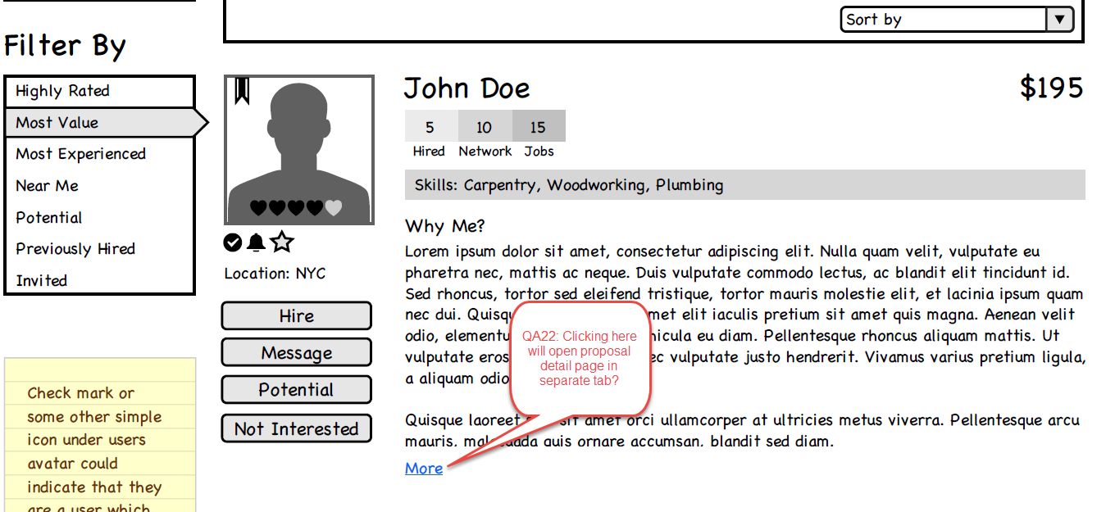

---------------------------------------------------------------------------------------------------------------------------------

QA23: This page is proposal detail page. Clicking here will open project detail page is separate tab?QA23

QA24: What is the purpose of Edit Project here? I assume we are not allowing edit project once someone has bid on it.QA24

QA25: I assume this is Average rating of doers who sent proposals for this project.

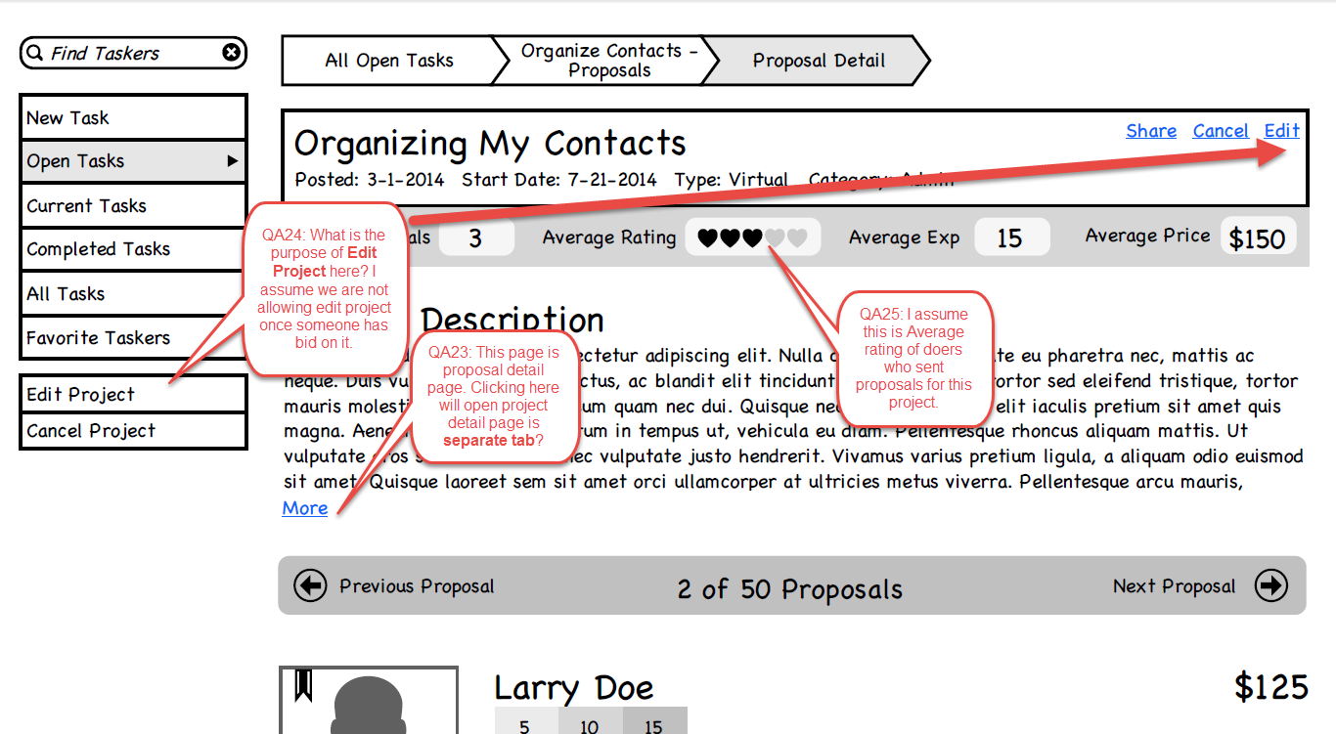

---------------------------------------------------------------------------------------------------------------------------------

QA26: I assume you asked to keep only one total. Please confirm the difference between these two or whether to keep both or which should be eliminated.QA26

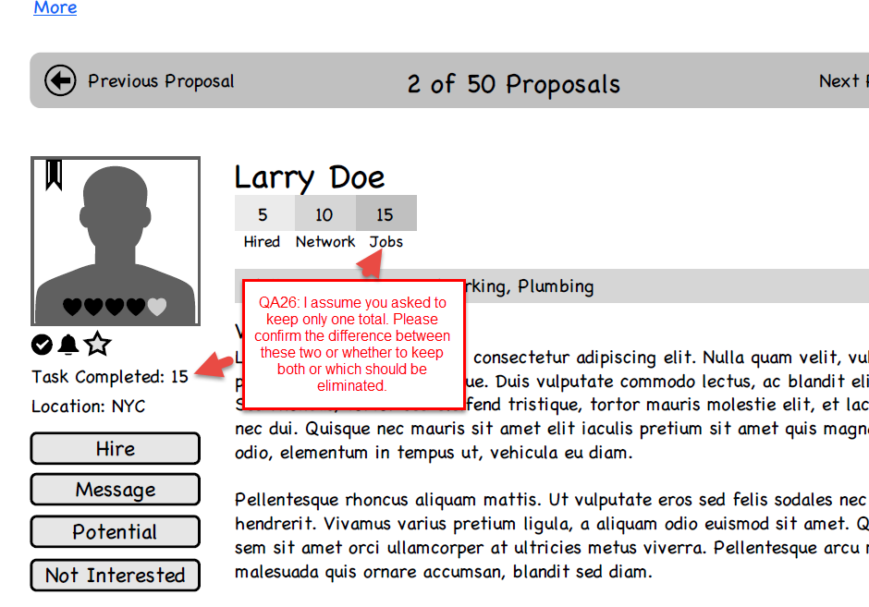

---------------------------------------------------------------------------------------------------------------------------------

QA27: Is the start date same as project award date?QA27

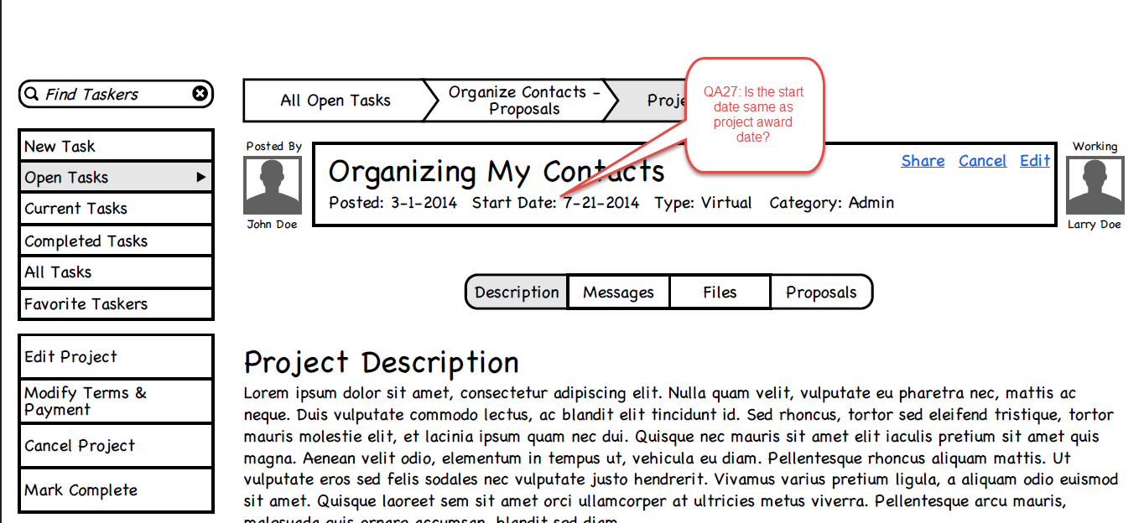

---------------------------------------------------------------------------------------------------------------------------------

QA28: Which file formats are allowed when doer submits proposal? Can doer upload audio/video file as proposal?QA28

---------------------------------------------------------------------------------------------------------------------------------

QA29: Will this mark most recent project as unread?QA29

QA30: Will there only most recent message be displayed here or poster can see complete communication of this project on this page. We can place inbox detail page link to view full communication for this project. Please elaborate the flow.QA30

QA31: Can we use progress bar to display time left or time elapsed for the project completion as an extra UI option?QA31

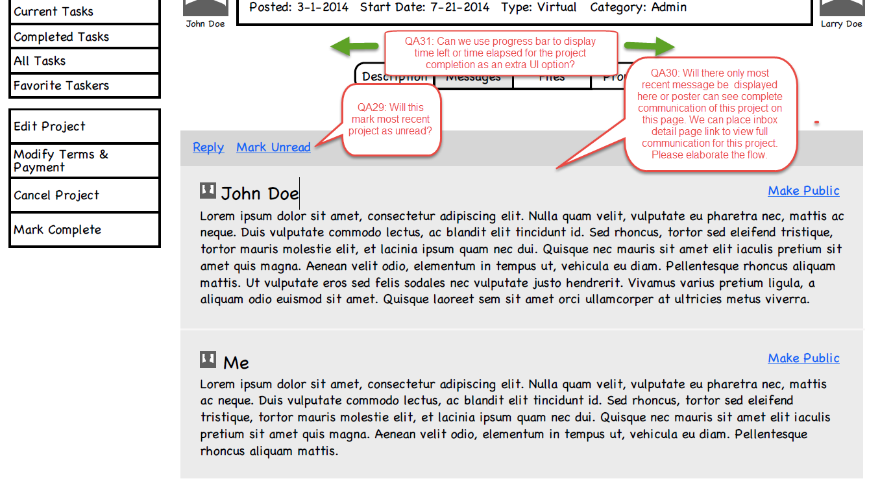

Create Task

We added an option to save the project details and publish it later by giving two buttons Save and Publish. When poster clicks on Publish current date becomes project post date. Matt

Is the start date same as project award date?

Can price range be unspecified by the poster?

Is the Estimated cost calculated by considering minimum value from price range?

Can user use someone else project as template?Matt

Are we managing space storage for each user?Matt

Which file formats are allowed to upload as project detail?Matt